Course Description: |  | The College Board's Course and Exam Description (CED) designates three course skills for AP Art and Design:  - Inquiry and Investigation - Investigate materials, processes, and ideas  - Making Through Practice, Experimentation, and Revision - Make works of art and design by  practicing, experimenting, and revising  - Communication and Reflection - Communicate ideas about art and design  Many important concepts and skills in the visual arts are connected to an understanding and  exploration of the Elements of Art and Principles of Design.  Students will establish foundational knowledge of these concepts at the start of the course, and continue to develop their understanding and use of them throughout the school year.  Course Structure:  This course is divided into three distinct sections that correspond with each of  the steps in this process: Exploration, Investigation, and Application.  EXPLORATION - This course will begin with an exploratory curriculum: you  will be encouraged to try several different media, tools, and techniques,  and given resources and prompts to explore modern and contemporary  art and art-making. The key of this phase of the course is to keep an open  mind and try new things, and to not devote too much time or energy to  one single project or idea. During this phase, we will be focusing much of  our attention to daily prompts in our sketchbooks. Each prompt will  center around one or more of the Elements of Art or Principles of Design  AND a modern or contemporary artist. Our projects during this phase will  entail expanding upon concepts and ideas explored in Sketchbook Prompts.  INVESTIGATION - Partway through the first semester, you will begin work  on your Sustained Investigation. Using the sketchbook prompts and projects completed in  the Exploration phase as a guide, you will develop an artistic and ideological focus for a portfolio of related works that you will be working on from this point all the way through the second semester. This phase will involve largely self-guided research, writing, creating prototypes, and work in your sketchbooks. If you are applying for arts colleges or other  post-secondary programs that require a portfolio for your application, then you can align the needs of the application portfolio to your Sustained Investigation.  APPLICATION - Once you've determined the subject of your Sustained Investigation, you will formally plan out your works and spend the majority of class time working on them. You will be expected to create and adhere to a schedule for creating your artworks, and receive regular feedback from both your peers and your teacher. During this time you will submit Biweekly Progress Checks: these mini-reports will be completed every two  weeks and update your teacher on the progress of your work. Students submitting AP portfolios will also be composing the written elements of their portfolios at this time and preparing their works for submission to the College Board. The Application portion will end in early May.
Classroom Management Plan: |  | Classroom Management Plan  - Verbal reprimand  - Conference with student with parent contact  - Withdrawal of privilege(s) with parent contact  - Other consequences determined to be reasonable and appropriate by the school administration.  Cell Phones  Cell phones and earbuds/headphones will not be allowed to be used during classroom instruction time. Phones and earbuds/headphones will be put away in a location designated by the teacher and placed in silent mode. In secondary schools, students will have access to their phones and earbuds/headphones outside of classroom instruction time such as between classes and lunch. Failure to follow these procedures will result in a disciplinary referral to the office.
Grading Policy: |  | GRADING:  CLASSWORK - 40%  Classwork during the first and second semesters will differ slightly on account  of our course structure. During the first semester, sketchbook pages will  comprise a large portion of the Classwork grade. During the second semester,  the Classwork grade will depend primarily on Biweekly Progress Checks.  PROJECTS - 40%  This is an evolving component of the course that will be tailored to individual  student needs and explained in further detail in the coming weeks.  WRITTEN ASSIGNMENTS - 20%  This includes the assignments completed during the Investigation Phase  (including all assignments associated with the Sustained Investigation Inquiry  Proposal) as well as the written elements of the AP portfolio and project  write-ups
Materials and  Supplies Needed:  Laptops  Accommodations |  | Materials:  Every student should have a dedicated sketchbook for this course. The sketchbook  should be at least 5"x7" (A3, A4, A5, 6"x9", 8"x10", 8.5"x11" and 9"x12" sizes are also acceptable) and have either mixed media or watercolor paper inside (usually, this  paper is 98lb or 140lb: it's thick and weighty compared to printer paper).  This SKETCHBOOK will be called YOUR PROCESS JOURNAL! A crucial place for the majority of your thinking, exploration, process, etc. Some of these pages may even end up in your AP Portfolio.  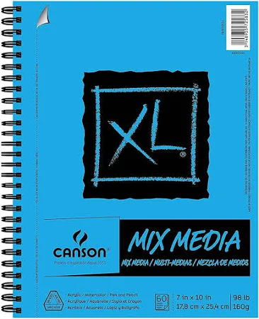  I would also encourage you to purchase some type of container to carry and store your art supplies.  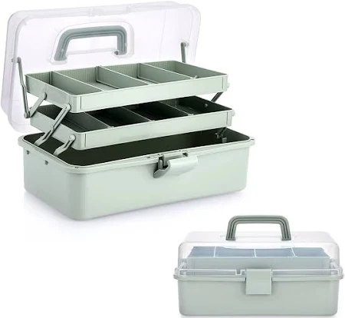This is just one example, you can find whatever works for you.  I would also encourage you to purchase a large portfolio to safely carry your artwork to and fro school and your home. OR I have some that you can borrow for the school year.  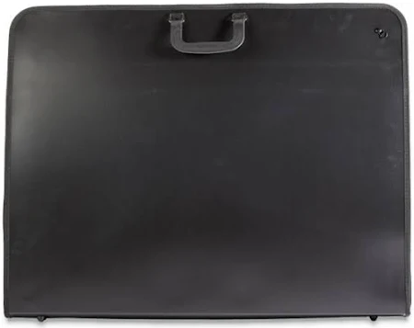  Concerning laptop utilization: 1.Student laptops should not be hard-wired to the network or have print capabilities. 2. Use of discs, flash drives, jump drives, or other USB devices will not be allowed on Madison City computers. 3. Neither the teacher, nor the school is responsible for broken, stolen, or lost laptops. 4. Laptops and other electronic devices will be used at the individual discretion of the teacher.  Requests for accommodations for this course or any school event are welcomed from students and parents.
Example: 18 – WEEK PLAN*
Weeks 1-3 | Unit 1 Exploration
Weeks 4-7 | Unit 2 Exploration/Investigation
Weeks 8-10 | Unit 3 Investigation
Weeks 11-15 | Unit 4 Investigation/Application
Weeks 16-18 | Unit 5 Application
Week 19 | Application

*This is a tentative plan and may change at the discretion of the teacher.

Please sign below to acknowledge that you have received, read, and understood the syllabus.

Student name: ___________________________________

Student signature: __________________________________

Parent/guardian name: ____________________________

Parent/guardian signature: ____________________________

Parent/guardian, please provide two ways for me to contact you (email address, phone numbers):

Parent/guardian Email:

__________________________________________________________________________________________

Parent/Guardian Phone number:

__________________________________________________________________________________________

